**Supermarket Stock Management System**

**Final Project: Data Structures & Algorithms**

By: Ellis Mapakama (2301960024)

Faith Chioma (2301960106)

Misa Xirinda(2301962982)

Abstract:

For every upcoming small supermarket that has to have extra goods that will resupply the shop once they run out there is a need for a warehouse that will store the goods so that the shop never runs out. With the use of a warehouse there is a need to maintain proper records of the goods brought in and the goods that are transferred to the shop. For small scale supermarkets who cannot afford high end stock management systems they usually use books to store their records, this method lacks security since it is easier to access and manipulate records and also the books are prone to destruction from fire or water hence you lose records easily.

The Stock Management System we are going to develop is tailor made for small scale supermarkets that have their own warehouses. This will be an easy to implement system which offers better security to their records and the system can be later merged with their point of sale system.

**Solution Design**

Choosing Data Structure:

In order to get the perfect data structure needed for the system under development we had to look at the type of data that the system had to handle and then look at the type of operations that had to be done on that data.

The Data:

For this system there is a need to work around data that includes product name, barcode, delivery date, price and quantity. Each record must contain all this information.

The Operations:

The system must allow the user to do the following with the above data: insert a record, delete a record, view a single record, view all records and move a portion of goods to the store from any selected product.

With all this information we came up with the decision that we need to implement a singly-linked list.

Advantages of a Linked List:

* Is a Dynamic data structure
* Can grow or shrink during run time therefore using only the needed amount of space.
* Insertion and deletion operations are easier
* Efficient Memory Utilization, i.e. no need to pre-allocate memory
* Faster Access time, can be expanded in constant time without memory overhead

Other Secondary data Structures used:

Vector – this was used to store user’s information since the information about users is only needed when logging into the system.

A vector was also used to help with data extraction from the CSV file that is the external storage for the records.

We chose a csv file as our external storage file because a csv file is largely easier to implement.

The Stock Management System

The system that we are going to develop will offer the following functions:

* Create a user account for those who will be using the system. Account creation is monitored by the systems admin.
* The ability to add new goods/products into the system (csv file/database).
* The ability to view a summary of all the goods/products that are in the file.
* The ability to view details about a specific product.
* The ability to move some goods/products from the warehouse into the shop.

The goal of this system is to make a system that is affordable to small scale supermarkets and is easy to implement, easy to use and requires less computer resources whilst offering better record keeping and security features.

**Program Manual**

After launching the program the following menu will pop up and gives two options either you choose login and input user-id and pin-code and gain access to the system’s main functions or choose the create account option which allows a new user to create their account that they will use in the future. In order to successfully create an account there is need to provide an admin password, this serves as a security feature so that only authorised personnel get to create accounts.

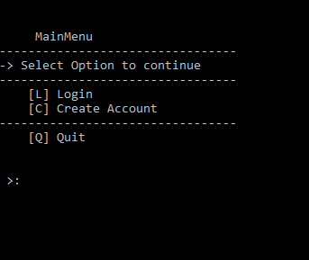

Products Main Menu:

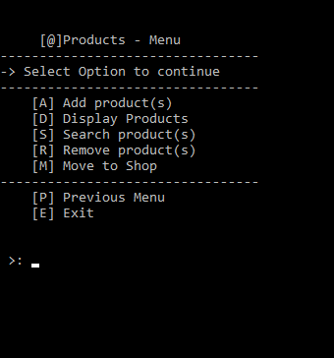

This Menu has the main functions used to operate the system. Add Products for adding new stock when it arrives, make sure to provide the necessary details especially the barcode and the batch number since these are unique identifiers for each record.

Display product will display all records saved in the csv file .

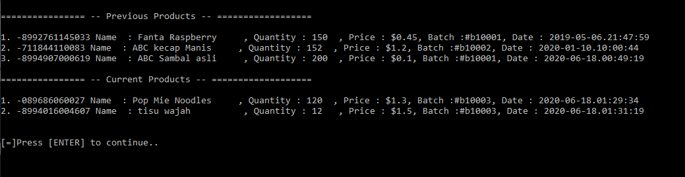

Previous Products refers to those products that have already in the csv file whilst Current Products has those products that have been recently added into the Linked-list. Writing to file is done when you log out or quit the program.

Search Product works more like display product but this one is specific to a single product where you have to provide the barcode of the product and its details are displayed.

Remove Product is used when you want to delete records associated with products that you no longer need in your system. Provide the barcode of the product that you want to delete and then delete.

Move To shop is used when there is a need to transfer part of the stock from the warehouse to the shop for retail purposes. In order to efficiently move goods you have to provide both the correct barcode, the batch number and quantity of the product that you want to move. The quantity is then deducted from the stock.

Previous Menu log out a user, so in order to continue you need to log in again while Exit is for exiting the program completely.

Video For the Program demo will be uploaded in the Github Repository.

Link: <https://github.com/ellispax/BINUS_Semester_2/tree/master/COMP6571DSA>

**Conclusion.**

The goal of the Stock Management System is to provide a simple but secure and reliable system that allows small scale supermarkets to efficiently keep records of their stock goods giving them better security and Presentability while the whole system is affordable.